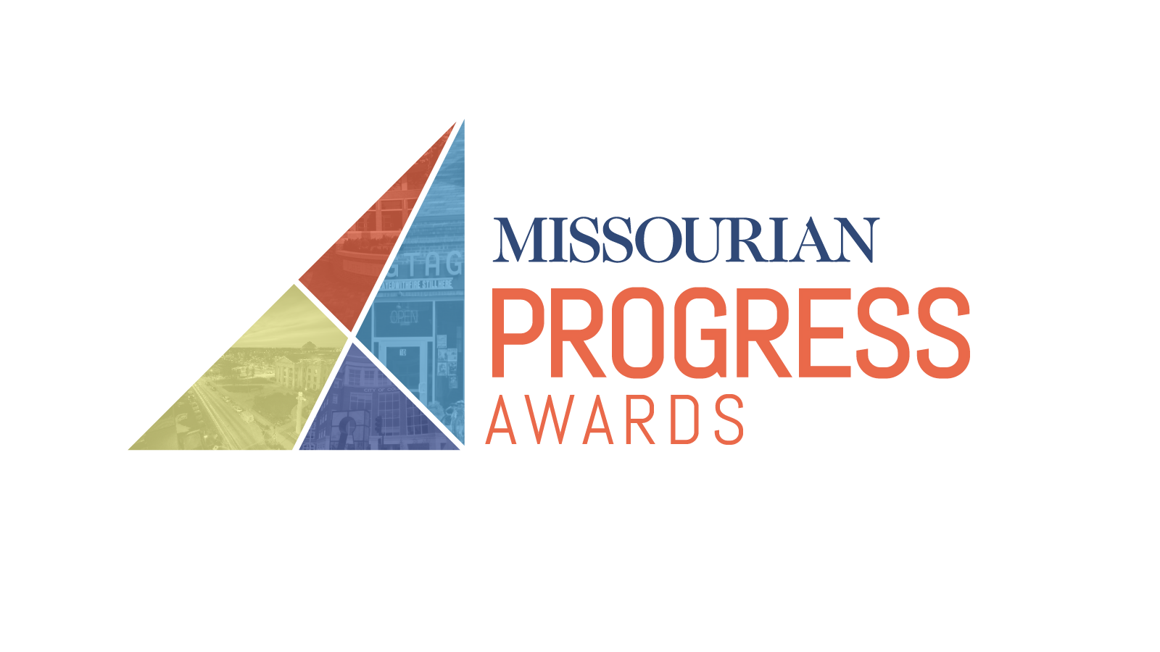

**Honoring those who move  
our community** *forward*

The Missourian is hosting the second annual Progress Awards. The program is designed to lift up people who are engaged in our community who may not be recognized for their contributions otherwise.

We want to recognize the people and organizations that help make Columbia a great place to live, work and learn.

HOW TO NOMINATE

All nominations must be submitted online. You may nominate as many people (or organizations) as you like for as many categories as you like. The last day to submit nominations is Oct. 26. Access the nomination form directly at http://bit.ly/progressawards.

AWARD CATEGORIES

* Progress in Education
* Progress in Health Care
* Progress in Social Justice

573.882.5700

221 S. Eighth St., Columbia

columbiamissourian.com

* Progress in the Arts
* Progress in Sustainability
* Progress in Entrepreneurship
* Progress in Philanthropy
* Progress in Civic Engagement
* The Sherman Brown Award
* Corporate Citizenship